Title : Behavioural Wakefulness Verification System (BWVS)
Team Members :
- Aswin Raaj .R
- Mani Balaji .S
- Tharun .V.S
Problem Statement:
- Conventional alarm systems cannot verify genuine wakefulness after alarm dismissal.
- Existing solutions fail to detect post-alarm sleep relapse effectively.
- Wearable and camera-based systems reduce comfort or raise privacy concerns.
Abstract:
Behavioural Wakefulness Verification System (BWVS) is an embedded, non-contact wakefulness verification system designed to ensure a user is genuinely awake rather than simply dismissing an alarm. Unlike conventional alarm systems, BWVS treats waking up as a multi-stage approach consisting of a cognitive challenge, behavioural verification using a 24 GHz mmWave radar sensor, and wake stabilization. Controlled by an ESP32-S3, the system uses a finite state machine and session logging, forming the foundation for an advanced evidence-based wakefulness verification framework in Phase 2.
Components Required:
ESP32 – S3 Dev-Kit module, HLK-LD2410C 24 GHz mmWave Radar Module, DS3231 RTC Module, MicroSD Card Module (SPI), MicroSD Card, Active Buzzer, LEDs, Momentary Push Buttons,
Methodology:
The proposed BWVS is built using a Finite State Machine (FSM) architecture with four main stages: Alarm, Cognitive Challenge, Behavioural Verification, and Wake Stabilization. Once the alarm is triggered, the user must complete a cognitive challenge to prove responsiveness. The system then uses a 24 GHz mmWave radar sensor to observe the user's behaviour and verify sustained wakefulness. Finally, the wake stabilization stage ensures the user remains active before ending the session. All session data is stored on an SD card for analysis and future improvements.
Novelty:
- Multi-stage wakefulness verification instead of conventional alarm dismissal.
- Non-contact behavioural monitoring using 24 GHz mmWave radar technology.
- Cognitive challenge combined with behavioural evidence for wakefulness verification.
- Wake stabilization mechanism for detecting post-alarm sleep relapse.
- Modular embedded architecture designed for future evidence-fusion intelligence.

Benefits:
- Verifies actual wakefulness instead of simple alarm dismissal.
- Uses non-contact mmWave sensing for reliable behavioural monitoring.
- Reduces sleep relapse through multi-stage wakefulness verification.
- Logs wake-up session data for behavioural analysis and performance tracking.
- Provides a scalable embedded platform for future intelligent wakefulness research.
Block Diagram:
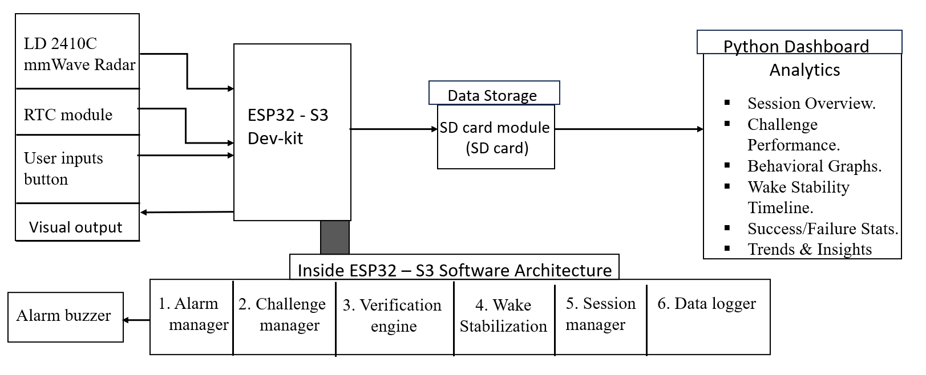
Fig. Behavioural Wakefulness Verification System (BWVS)

Timeline: 3 to 4 months

----------------------------------------
Signature of Mentor

